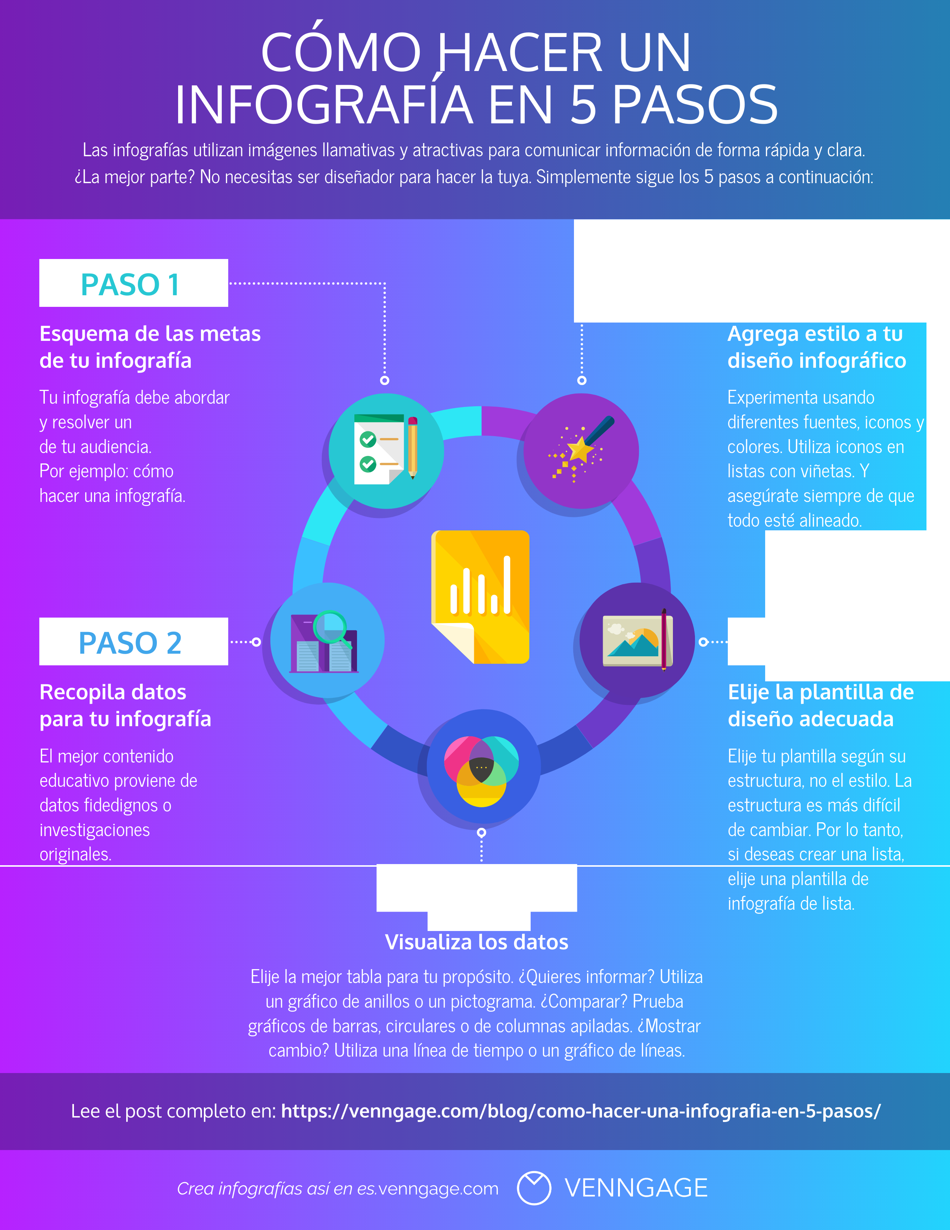

...............................

PASOS

PAS04

PAS03